Ping Pong Cannon

In this project we decided we would make a ping pong launcher that would exceed the speed of sound, we could accomplish this by having a vacuum chamber with the ping pong ball within it. We would then use pressurized air that would help propel the ping pong ball out of the vacuum faster than if only atmospheric pressure would launch the ping pong ball. Some calculations we did include:

Determining the stress upon the PVC tube wall:
Π 42 4
σ= ______ P= ______
2π4 / 0.237 2*0.237

Bernoulli's equation for the constriction in the tube:
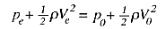
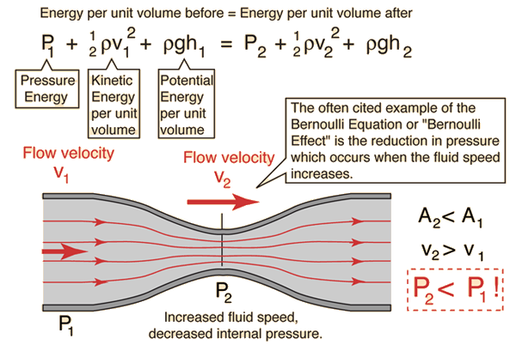
We desire a drop in pressure for an increase in the speed of the fluid (air) to launch the ping pong ball at the highest possible speed we could.

Velocity using kinetic energy

$Ke=1/2∙M∙v^{2}$
$e=f∙d$
$f=p∙a$

$KE=p∙a∙d$

$p∙a∙d=$$1/2∙M∙v^{2}$

$v=\sqrt{\frac{pad}{2M}}$

KE = kinetic energy
M = mass
f = force
p = pressure
a = area

